

Hopper EY Promoter’s Toolkit

“everything you need to know to market and host your own show”

Why does Hopper exist?
Hopper is a theatre initiative specially for under 5s and their families. The project aims to ensure fabulous quality shows are easy to access by taking performances into Early Years settings. Children and their family members can share a quality experience, providing a rich source of inspiration for developing minds.

This toolkit guides you through the 3 main areas of organising an EY show including marketing, hosting and the day itself.

1. Marketing
Your audience

You have 3 main audiences to market your show to

- The children
- The parents/family members
- Neighbouring settings (including childminders and home educators) and their families

Key lesson from our pilot - start early!
Parents/family members
A drip, drip approach works best for parents/carers to help build confidence in the idea.

“I did not know how my child would react so I didn’t really want to make a huge effort or expense but after seeing the show I think I will try more theatre with him”
Parent comment after a Hopper show

Neighbouring settings
Start conversations early to ensure that your proposed performance times allows visiting settings to get to you and back comfortably within their timetable.
It also allows time to organise transport.

Key lesson from our pilot - Parents can be vital here. During our pilot, one parent from a neighbouring school organised transportation for the entire reception class by galvanizing parents to take children by car.

Childminders and home educating groups also love being involved and have the flexibility to do something different.

Your tools
Think about promoting the show in different ways using different channels to suit your particular audience.

Channels
- Setting website
- Setting newsletter
- Setting social media
- Local newspaper
- Local Authority EY newsletter
- Local Authority Social Media
- EY cluster group meetings
- Word of mouth

Promotional material
- Show flyers and posters for your setting and externally e.g. libraries, children centres, toddler groups
- Bespoke letter to parents (example letter to adapt at the end of the toolkit)

Can other staff help with marketing?

The more staff that are engaged pre-show the better. There’s always someone who loves facebook, it doesn’t have to be you!

Hopper will provide

- Flyers and posters from the company with your show details included on them
- Web copy, images and Hopper logo for you to put on your website/social media
- A project explainer highlighting the importance and value of EY theatre
- Partnership statement acknowledging funders
- Skeleton press release
- Hopper branding e.g. t-shirts, stickers, pop up banner

Selling tickets

Hopper is about making EY theatre more accessible to all and as such we do not want cost to be a barrier. However, it is important to value quality EY shows and a small charge will help recognise the work that goes into producing and organising this event as well as recouping the cost of buying in the show. This would be line with any special event/activity that you bought into school e.g. author event, space dome science event, sports event. We suggest a small charge, around £2 a ticket, with the usual caveats that would be placed around a school trip or activity.

Key learning from our pilot – set up a system to keep track of who’s paid, both children and parents and encourage your visiting settings to do the same. You’ll want to know how much you’ve made in ticket sales to offset the cost of the show.

Settings choose different ways of administrating their “box office” depending on their infrastructure. Ideas include

- Eventbrite (involves a fee)
- ParentPay
- Simple excel spreadsheet keeping track of ticket sales and audience numbers

Again, the administration of ticket sales doesn’t have to come down to you. Involving other staff in the process means there’s more people on board to market and talk about the performance as well as keeping track of the money. Could your setting office help here?

Hopper will provide
- Bespoke ticket book
- Hopper stickers to help identify your audience on the day

99% of parents said they would like to see their EY setting to host more live performances having seen a Hopper show.

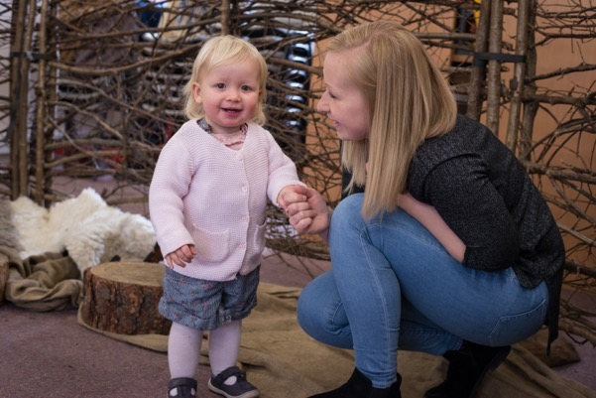



2. Hosting a theatre company

Building a relationship with your company before the show itself is essential.
Time spent doing this pays dividends for smooth sailing on the day itself.

The company may load the van, drive down the day of your show, set up, perform twice, clear away and drive back again so the more you help them beforehand, the better.

Some companies are relatively new to performing away from a theatre environment. If they don’t ask you some of the questions below, feel free to provide the information to them. You’re an expert in knowing your own setting and your audience. They’re experts in providing a high-quality engaging show. Hopper aims to build a collaborative relationship between company and setting.

The company will want to know

- Mobile numbers for the person meeting them on site (often the caretaker) and the EY promoter (probably you!) in case of questions

- How to get to you? Does the setting postcode actually get you there?

- Where to park and where to go on arrival?

- Who will be there to let them in? Best time to unload the set ahead of children/staff arriving on site

- Is there anyone to help carry equipment if needed? Caretakers were key to the success of the pilot for many reasons, this being just one.

- Configuration of the room e.g. do you have a fixed stage space, location of plug sockets?

- Will they need to have a DBS certificate?

- Confirmation that the company has the performance space for the duration of the day e.g. if you’ve worked out a way of staggering lunches in part of the hall for instance, it’s worth running this past the company to make sure they’re on board with this.

- Likely audience numbers and whether audience is from your setting/visiting/both.
If it’s an audience of visiting settings, the chances are they will all arrive at different times. The company may be able to entertain some of the audience while they wait if they know beforehand.

- Is there a space that they can get changed and have some time undisturbed to prepare for the performance? Ideally this would be
- a clean, warm space to change.
- a place for hanging costumes, chairs, table or similar flat area, and a mirror
- access to a loo
- access to the kitchen if possible

Key lesson from our pilot - If you have chosen a dance show please talk them through the type of floor they will be performing on. Some surfaces might need additional planning e.g. concrete.

You will want to know

- Mobile number for company member involved in the production on the day

- Estimated time of arrival and how many people to expect

- Additional access requirements – e.g. wheelchair user

- Confirmation of the set-up time and clearing away time

Key lesson from pilot – after school clubs! Will the space be free in time for these to go ahead and if not, what alternative plan could be put in place?

- Do they need help getting the set in?

- Do they need food whilst they’re with you?
You may want to offer a school dinner/facility in a staff room for the company to prep their own food or you may want to recommend somewhere off site.

- Will the company be bringing seating as part of their set or will you need benches/chairs at the ready for audience members, particularly adults?

- Will the company invite the audience to take their footwear off to enter the set?
It’s worth thinking about a way of organising this, companies don’t always appreciate the fun involved in helping young children to take off their shoes and most importantly find their own pair of shoes to put back on again. Parents also might appreciate a heads up to help with their comfort zones here.
- Is there is a post-show activity and how will that work with timings etc?

The legal bit
Hopper will send you as the promoter, a promoter booking agreement form to fill in stating that you are happy to host the show in the space nominated for the fee agreed.
It asks you to confirm that you have risk assessments and public liability insurance in place for the space the performance takes place in. If you are hiring a space separate from your setting, it’s worth checking this at the time of booking.

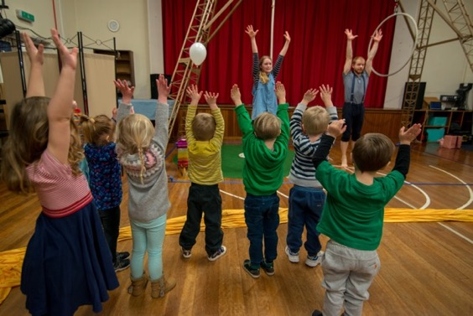

3. Show Time – the day itself
Things to consider

The company will transform your hall into a high-quality performance space. It’s worth thinking about whether anything could be tucked away for show day. Sometimes you stop seeing that life sized giraffe sitting in the corner. It might just prove distracting during the performance itself.

Who will support you in your dual role as host and EY practitioner? e.g. Do you have a TA/other member of staff who could bring your class to the performance, leaving you free to welcome parents, neighbouring settings? Or vice versa?

How will you organise the audience? During our pilot it was clear that parents and children got the most out of the show when they could sit together to watch it. If this is possible some clear messaging around who is responsible for children’s behavior is important.
Children were mesmerised by the shows - the concentration and enjoyment were plain to see on their faces. The reaction of the parents experiencing their children's enjoyment of both shows had a huge impact.” Early Years Practitioner who invited family members to watch the show side by side with their child
Does there need to be a marker or person stationed near the performance area to gently stop children wandering onto the “stage”? This can be discussed on the day with the company.

Key lesson during pilot - Explore whether it would be feasible to switch off the school bell if it is due to ring during the performance.

Introduction

In collaboration with the company, decide on how/who best to introduce your show to your audience. Evidence from the pilot suggests that a live theatre show, all be it in a familiar setting to a parent/guardian, challenges comfort zones. Adults worry they won’t understand it/feel stupid and that there would be an expected way to watch the show that neither they, nor their child are aware of. A friendly, clear introduction helps address these fears.

An example for you to adapt is below, please remember to include general housekeeping such as location of toilets, fire evacuation plan within your introduction for the comfort of your audience.

Hopper suggested welcome

“We invite all of our audience to relax and enjoy the show. We encourage children to enjoy the show however they like. This might mean that they giggle, wriggle, call out, get excited and even narrate the show. All these responses are welcome. It might be that some of our young audience need a bit of space and quiet. If this does happen we would encourage you to take them to the back of the space for a bit of distance. Children may need to come and go more than once and this is perfectly fine”

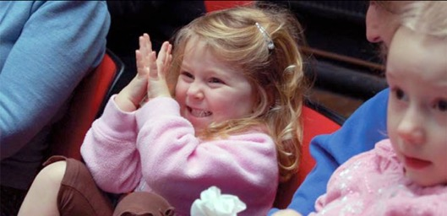

EY Promoter Checklist

- Select your Hopper show
- Agree time and date of show in collaboration with your setting staff/Hopper team
- Sign and return the promoter booking agreement form
- Book space and if within setting, communicate to all that the area is out of operation on day of show (include after school clubs if appropriate)
- Share the load, delegate jobs to other staff e.g. caretaker, TA, office staff
- Set up a system for keeping track of ticket sold – involve other staff from your setting to help with this
- Market your show to your audience using the best channels to maximise parent engagement – involve other staff from your setting to help you with this
- Invite neighbouring settings, childminders and home educating groups
- Put up show posters around your setting to build a buzz and ensure everyone knows about the special event you’re organising
- Communicate with company over logistics to aid planning
- Order lunch for the company if appropriate
- Nominate people to help you manage your dual role of host and EY practitioner on the day
- Practise your Hopper welcome
- Switch off the school bell if appropriate for the show itself

Take Art contact details
earlyyears@takeart.org
takeart.org
01460 249450
Take Art, Flaxdrayton Farm, South Petherton TA13 5LR

Example parent/carer wording for a letter to promote you Hopper show

Dear Parents,

On DATE at LOCATION we will be hosting a special performance called NAME OF SHOW by COMPANY. The show is a BRIEF DESCRIPTION OF SHOW e.g. a funny dance performance playfully exploring silence and noise.


The show is suitable for children between two and five years of age (and their grownups.)
The performances will last for XX minutes with a showing at XXam and then again at XXXpm.
Other schools, nurseries and families in our area will be invited to come and share the experience with us.

The performance is part of a pilot project called Hopper which aims to make it easier to see an Early Years show and to demonstrate what a rich shared learning experience it can be. We are lucky to be able to offer the show at a specially subsidised price of £2 per child.
We would encourage parents to join us to see the show with your child. Younger siblings are also welcome. Parents and young siblings’ tickets would be XXXXXX

INSERT TEXT ABOUT HOW TO GIVE MONEY e.g.
Please send the money in a sealed envelope clearly labelled with your child’s name by XXX.
Many Thanks
Your name

……………………………………………………………………………………………………………………………………………….
I give permission for my child ................................................................ to attend SHOW TITLE by COMPANY NAME on DATE at LOCATION

Please cross out as relevant: I will / will not be attending.

I will/ will not be bringing .... younger siblings aged:..........

I enclose a voluntary contribution of £2 per child.

Thank you

