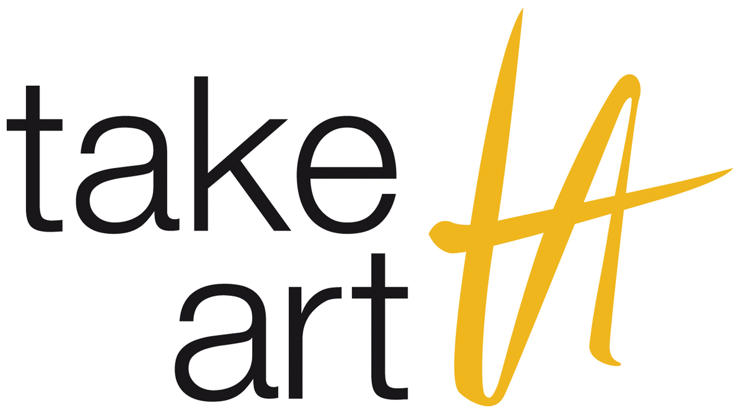 |  | 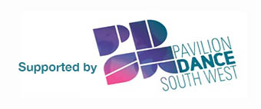

Application Form for U.Dance 2020
Sunday 29th March
The McMillan Theatre, Bridgwater, Somerset, TA6 4PZ

This regional platform is a celebration of all styles of youth dance from across the South West for ages 11-19yrs (*Disabled dancers up to the age of 25 are eligible to apply), an opportunity for youth dancers to inspire and be inspired, connect and perform. It also acts as the selection event for groups wanting to go onto the National U.Dance Platform happening on the 17th – 19th July in Glasgow.

An independent selection panel will consider all submissions and will be looking for dance groups that:

1. Demonstrate excellence in performance standards.
2. Demonstrate Integrity and authenticity of choreography.
3. Demonstrate a strong example of the dance style/genre they are performing.
4. Give 100% commitment to their involvement and respect all those involved.

In ADDITION to the written application you must submit a video of your work (which can be a work in progress) between 1-2 minutes long. Refer to Film Guidelines.
Please complete all sections of this form in FULL. Refer to the Information & Guidance Notes attached when completing this form. https://takeart.org/u-dance-2020
& Information about U.Dance 2020 here: https://www.onedanceuk.org/u-dance-regional-events/

In order for your work to be considered by our selection panel, we will require you to submit footage of your piece and this form by 5pm on Friday 31st January 2020. The form, including the link to the film footage need emailing to nadine@takeart.org.

For further information about the regional platform go to: https://takeart.org/u-dance-2020

For further information about the national platform and guidelines go to:
https://www.onedanceuk.org/u-dance-regional-events/
Please complete this form in type, or if necessary with black ink in BLOCK CAPITALS.

Section A - Contact details
Name of Group/ Company
Name of Group Leader
Correspondence address
(Please put name of contact for administration purposes if different from above)
Contact Tel. Number
Contact Mob. Number
E-mail Address
Section B - About the Group
Where is the group based?
How often does the group meet?
How long has the group been working together?
What dance styles does the group perform?
Do any of the group leaders or dancers have any access requirements?
How many dancers are there in the group? (Max 30 dancers)
Please state the age range of your dancers
*Dancers should be aged 11-19 or up to the age of 25 if they are disabled.

Section C - Equal Opportunities
Ethnic Origin
Please list the ethnic origins of the young people in your group, along with the number of young people that consider themselves to be from that ethnic origin | Ethnic Origin | No. of young people
Prefer not to answer
Disability
No. of young people in group who consider themselves to be disabled
Prefer not to answer
Free School Meals
No. of young people in group entitled to free school meals
Prefer not to answer

Section D – Regulation Requirements
What insurance cover do you have for your work with the group?
Chaperone/Licensing | Please read thoroughly the guidelines for Child Performers Licensing and Chaperones (pages 11 of the guidance notes)
Does the Group currently have the appropriate number of up-to-date local authority licensed chaperones? (i.e. 1 licensed chaperone per 12 members aged 16 and under) | YES NO
 | If yes you will be expected to supply information of the chaperone licenses if selected.

Section E – The National Youth Dance Festival: U.Dance 2020
U.Dance 2020 will take place from 17th -19th July, in Glasgow.
Do you want your group to be considered for a place at U.Dance 2020? | YES NO
If yes and you’re selected for U.Dance 2020, how do you intend to raise the funds to pay for accommodation and transportation for your group to the national festival?
I confirm I have read the Application Guidelines produced by One Dance UK for U.Dance 2020, available from https://www.onedanceuk.org/u-dance-regional-events/ | YES NO

Section F – About the Piece
Title of piece
Length of piece (between 2 and 7 minutes)
Choreographed by
Dance Styles Included
Title of Music & Composer/Artist/Musician
How are you supplying footage of your dance piece?
Is there a password to view the dance film? If yes, please provide it.
A description of the Company/Group/School (max 50 words):

Please describe the inspiration and concept behind the dance piece (max 50 words):

Section G – DECLARATION
I have read and understood the Information and Guidance Notes and have completed this form to the best of my knowledge
Signed: (we accept type)
Name:
Date:
Please tell us how you heard about
[regional event name]

Please return this completed form to nadine@takeart.org by 5pm on Friday 31st January 2020 or it will not be processed.

